Name _____________________________________ Date __________________________

Analyzing Sensory - Somatic Responses

There is more than one reflex arc. Figure 25-1 shows the patellar reflex that occurs when a tendon in the knee is suddenly tapped. The action causes a muscle to tense and raise the leg slightly. Simple reflexes such as the patellar are referred to as monosynaptic reflexes. Figure 25-2 shows what happens when the tip of the finger accidentally comes in contact with a flame. Just as the patellar reflex, the withdrawal reflex occurs immediately, without first having to involve the brain. Yet it is more complex than the patellar reflex shown in Figure 25-1, because it is a polysynaptic reflex.

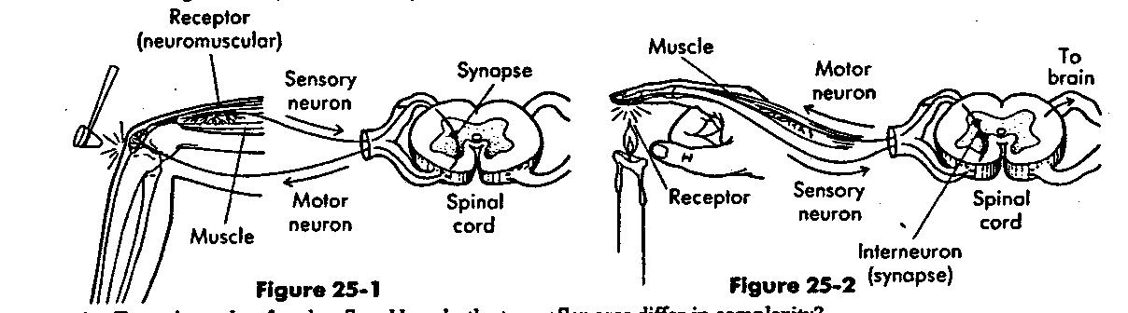

1. Trace the paths of each reflex. How do the two reflex arcs differ in complexity?

2. The interneurons involved in the polysynaptic reflex are also involved in the secondary response reflex. How do these interneurons function in secondary responses?

3. Why do you think a polysynaptic reflex is a more important adaptation than a monosynaptic reflex?

The Nervous System

Complete the table by filling in the missing information in each case.

Structure | Function
1. | carry impulses toward the brain and spinal cord
2. dendrites
3. motor neurons
4. | transmit impulses within the brain and spinal cord
5. | carry impulses away from the neuron cells bodies

Electrical signals travel throughout your nervous system, carrying information from one place to another. The nervous system is made up of the nerve cells, or neurons. The neurons have gaps between them, called synaptic spaces, which an electrical signal has to jump across in order to continue. In some electrical machinery, electrical signals jump across a tiny gap as a spark. In your body, an electrical impulse is passed by a chemical signal called a neurotransmitter.

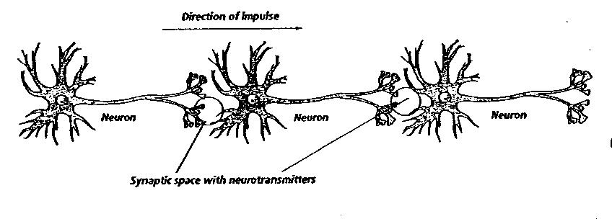

1. What would happen to your nervous system if the neurotransmitters in your body were suddenly blocked from passing into the synaptic spaces?

2. What do you think would happen if a lot of neurotransmitters were suddenly released throughout your nervous system?

